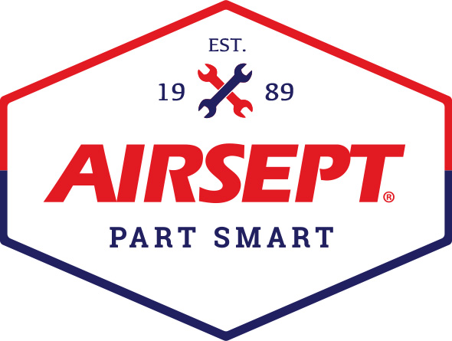

News Release

AirSept Introduces 2021 Automotive Product Catalog

Atlanta – May 27, 2021– AirSept, a leading innovative solutions provider for the automotive repair industry and manufacturer of the award-winning Smart Splice™ system of line and hose repair, is proud to introduce over 30 new SKUs in the company’s 2021 automotive product catalog.

The all-new catalog gives detailed product information, features and benefits, part numbers, product images and helpful repair advice for the entire Smart Splice line, including the Smart Splice Ultimate System and the new Pro Series assortments for Air Conditioning line repair and Transmission and Power Steering line repair. Smart Splice is the technician friendly, OEM approved line and hose connector system that takes only minutes to install. AirSept’s patented sealing technology provides a durable repair that saves time, labor and money.

New products added to this year’s AirSept automotive catalog include:
- Smart Splice ProSeries Transmission and Power Steering Assortment
- Smart Splice ProSeries Air Conditioning Assortment
- Smart Splice Line Terminator Y/M/M Application Kits
- Smart Splice Line Repair Extension Kits (for large repairs up to 24” long)
- Smart Splice Inline Service Valve Inserts
- Smart Splice 3-Way Metal Line Connectors

Both the Ultimate System and Pro Series assortments are packaged to include the connectors needed to quickly make line to line, hose to line or hose to hose repairs, with the use of straight, 45° and 90° fittings available in SAE and metric sizes. Smart Splice installs on the vehicle in five minutes or less, eliminating the need to remove or replace leaking lines.

The Smart Splice Ultimate System provides over 8,000 repair options and covers air conditioning, power steering, transmission, trans oil cooler, engine oil, heater and coolant lines with five pull out trays of fittings, connectors and tools. Each Smart Splice assortment – Ultimate System and Pro Series allows installers to quickly and effectively repair leaks without the hassle of removing the line(s).

AirSept’s Recycle Guard™ product offering also features two new part numbers this year, including the recently introduced Dual Recycle Guard with Quick Connect Fittings for fast, simple setup to protect A/C recovery equipment from debris, sealant, dye, excess lubricant and other contaminants. Dual Recycle Guard protects both the A/C system low and high sides simultaneously. Dual Recycle Guard is available for R134a and R1234yf equipment and works with all A/C service equipment.

For more information about AirSept’s technician friendly service solutions including the company’s original odor abatement products – Cooling Coil Coating that is approved by 16 vehicle manufacturers worldwide, visit www.airsept.com and download the 2021 catalog, or call 800.999.1051 or email information@airsept.com.
# # # #

Image Attached: 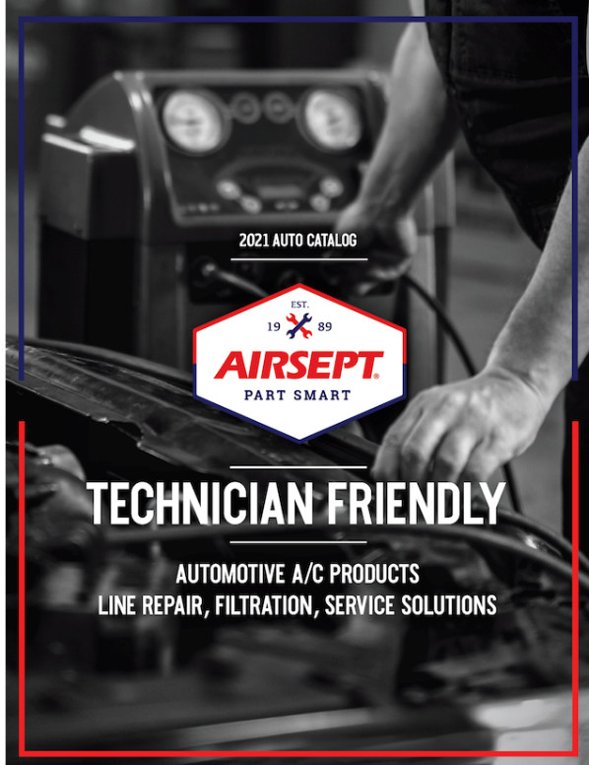

About AirSept
In 1989 AirSept created the first long-lasting solution to the problem of unwanted mold and mildew odor in automobile air conditioning systems. The product quickly became popular and in 1991 AirSept was incorporated as a company. AirSept began partnering with global OEMs and suppliers to not only market its Cooling Coil Coating, but to also develop other unique, new problem-solving products. From those humble beginnings, AirSept has grown to be the industry leader in the development of OEM and aftermarket solutions to complex automotive repair problems. AirSept products are designed to save time, money and labor. For more information, visit AirSept.com.

For further product information, contact:
Aaron Becker, President
AirSept
678-973-2287
abecker@airsept.com

Leslie Allen
Owner
Wildcat Communications
615-429-7965
leslieallen.wildcat@gmail.com

